What is conversation all about?:
How people talk and why it matters
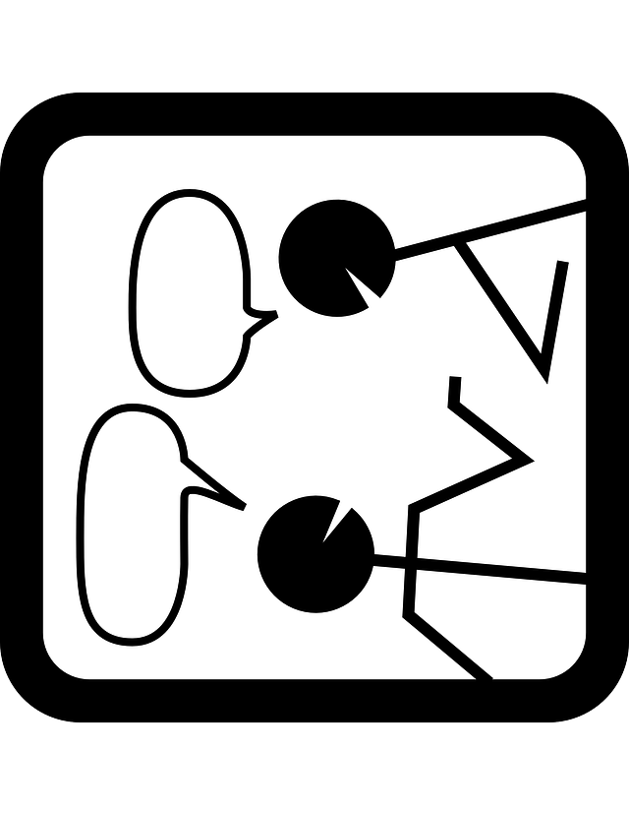

ARTSCI 113X.xx
Day: TBA
Time and Location: TBA

Professor: Carmen Taleghani-Nikazm
Department of Germanic Languages and Literatures
Office Hours: Wednesdays 1:00-3:00 and by appointment
438 Hagerty Hall
Email: taleghani-nikazm.1@osu.edu

Course Description
Talk is at the heart of our social life and it drives everything we do as humans. No matter where we are and what we do, we spend a good deal of time conversing with one another. We argue with each other, we complain about other people or what has happened to us, we justify what we did or are about to do, ARTSCI 113X.xx
Day: TBA
Time and Location: TBA

Professor: Carmen Taleghani-Nikazm
Department of Germanic Languages and Literatures
Office Hours: Wednesdays 1:00-3:00 and by appointment
438 Hagerty Hall
Email: taleghani-nikazm.1@osu.edu
we request a person to do something for us, or offer a friend a cup of coffee or help with studying for a test, we criticize someone’s or our own behavior or look, we entertain each other by telling funny stories, and etc. What’s amazing is that we do all of these in a very systematic way. In this seminar, we are going to discover that conversations is not messy, as one may believe, but are immensely organized. It is its organization that allows us to discover the difference a single word, stretch of sounds, phrases, silence, gesture, facial expression, and body posture can make to the outcome of the encounters like first dates, making an appointment over the phone, meeting with a professor, sales calls, or being interviewed by the police. We will learn in this seminar how to do a forensic analysis of conversations and thereby make incredible discoveries about the power of the language (verbal and nonverbal) that shapes our daily lives.

Course Objectives
- Become an analytical observer and thinker
- Learn about research on talk and conversation
- Practice critical analysis and thinking about social behavior

Require Texts
We will read and discuss a selection of texts that are available on our course’s Canvas site. We will also work with video and audio-recorded English conversations and their transcripts.

Course Requirements
Class participation: You are expected to attend class prepared and participate in the seminar discussions. Your participation will be evaluated based on how actively you contribute to the small group and class discussions.

Weekly Journal (250 words): Each week you will be required to keep a journal of notes on conversations. This means for each week’s topic you will make observations in your surroundings or conversations that you have been engaged in and jot down your observations. You will compare and discuss your notes with your classmates in small groups in class.

Analysis of samples of conversations: In class we will discuss the assigned readings and analyze recorded and transcribed actual conversations. These are excerpts of data which have been researched and published by social scientists. We will include your observations and notes in our data analysis and discussions of the readings.

Final Project: For the final project you will work with a partner (assigned by me) on one of the aspects of conversations or topics that we have discussed in class. Your project will explore the phenomenon more deeply by consulting your weekly journals with your partner and finding an example in a recorded episode of conversation; this could be a conversation excerpt from a TV program, a movie, a radio show, a podcast, or Youtube. You and your partner will give a 10-minute presentation on your findings to the class along with clips from your research.

You will be evaluated on the clarity of your presentation and your ability to connect it to our readings and class discussions.

Grading
Class participation 30%
Final Project Presentation 30%
Weekly Journals: 40%

Academic Misconduct
It is the responsibility of the Committee on Academic Misconduct to investigate or establish procedures for the investigation of all reported cases of student academic misconduct. The term “academic misconduct” includes all forms of student academic misconduct wherever committed; illustrated by, but not limited to, cases of plagiarism and dishonest practices in connection with examinations. Instructors shall report all instances of alleged academic misconduct to the committee (Faculty Rule 3335-5-487). For additional information, see the Code of Student Conduct http://trustees.osu.edu/assets/files/RuleBook/CodeStudentConduct.pdf

Students with Disabilities
The University strives to make all learning experiences as accessible as possible. If you anticipate or experience academic barriers based on your disability (including mental health, chronic or temporary medical conditions), please let me know immediately so that we can privately discuss options. To establish reasonable accommodations, I may request that you register with Student Life Disability Services. After registration, make arrangements with me as soon as possible to discuss your accommodations so that they may be implemented in a timely fashion. SLDS contact information: slds@osu.edu; 614-292-3307; slds.osu.edu; 098 Baker Hall, 113 W. 12th Avenue.

Biographical Statement

I am an applied linguist and teach undergraduate and graduate courses in the Department of Germanic Languages and Literatures. My research explores the relationship between talk (i.e., spoken language) and social interaction. I am interested in linguistic choices we make in conversations in relation to aspects of social context, speakers’ knowledge and understanding, and affect. I have published research on how speakers compose their turn-at-talk that can be understood as a request or an invitation. Or why speakers repeat each other’s turn and what they achieve by doing it. I apply my research findings to different learning contexts such as the German language classroom, teacher education and second language use. I teach courses on topics related to my research areas. I have also taught undergraduate courses on German culture and language. I have directed our study abroad program Berlin: People, Places, and Experiences.

WEEKLY SCHEDULE

WEEK 1: Introduction
Starting the conversation about our conversations! Conversation analysis: getting acquainted with the tool for forensic analysis of conversation, analyzing recordings and transcripts of real talk.

WEEK 2: Turn-taking
Conversation is a joint activity that involves people taking turns at speaking. Similarly to dancing, surgery, and roadwork it is highly coordinated, requires organizing and managing the talk of the persons who are engaged in it. We learn about what is involved in taking turns to speak in various contexts including conversations among friends, in the classroom, in a patient-doctor conversation.

WEEK 3: Action and understanding
A turn-at-talk performs an action, and they will appear in series. For example, a turn-at-talk may be a question which then leads to an answer, or it could be a complaint which may lead to showing affection such as sympathy or the opposite. We learn what actions speakers’ turns-at-talk perform and how to figure them out.

WEEK 4-5: Preference
The request “can you get me some food on your way home?” can be either granted or rejected. This can be done in many different ways. For example, by saying “sure”, “I guess”, or rejected by saying “uhm, I’m tired”, “well, I actually have no money on me”, or “no way!”. Accepting, declining, granting, and rejecting are different types of responses. The way we respond to questions or requests, for example, shows our alignment with the question or not. So, we have choices when we respond to someone, and depending on the circumstances and our relationship with the person, we choose different types of responses.

WEEK 6-7: Sequence
A great deal of talk is organized into sequences and paired actions. For instance, a question creates a “slot”, “place” or “context” within which an answer is expected next. A question like “do you know what time it is?” expects an answer that provides that information. When an appropriate answer is provided, speakers show that they understood the answer. An absence of an answer is noticeable and speakers take measures to show that. Or when we hear a friend saying, “Guess what happened to me?” we anticipate some sort of news or story. The expected response would be “what?”, which gives the person the green light to tell the story or news.

WEEK 8-9: Repair

When we talk to each other we encounter problems of hearing, speaking and understanding. For example, we may use the wrong word or cannot find the exact word that we want. Or we may find ourselves in situations where we cannot make out what has just been said or don’t know who or what is being talked about. When such situations develop, we have resources (verbal and non-verbal) to deal with such situations and “repair” the problems.

WEEK 10: The anatomy of turn-at-talk
We can compose our turns-at-talk in many different ways and form different actions. For instance, we can have someone do something for us by formulating a question and saying “can you please close the door?”, or we can give an order and say “close the door!”, or we can just make a gesture and point to the open door. Depending on the context, our relationship with the person and the situation in which we find ourselves, we choose specific words, formulations, intonations, and gestures to converse with others.

WEEK 11: Stories
One of the things that we repeatedly do in conversation is tell stories. We compose the first turn as such to indicate to our partner that we are about to tell a story, which means we’re going to talk for longer time. For instance, when you say “you have no idea what happened to me the other day”, you signal to your partner that you have story to tell him or her, and your partner may show interest in hearing what happened to you and say “what happened?” or not.

WEEK 12: Opening and closings
How do we begin a conversation over the phone, for example. And how do we bring a conversation with a friend to a close. These are so ordinary and so much a part of us that we hardly notice them and yet they are highly organized and we have resources (verbal and nonverbal) available to us to open and close conversations, smoothly or abruptly, depending on the situation.

WEEK 13: What are the benefits of analyzing conversations?
Studying conversation in a systematic and scientific way can have a big pay-off for us and many professions. The way we describe ourself has consequences for how we are understood by other people, the verb or adjectives, the grammar, the intonation, and body language we use, who we are and sometimes has serious consequences, for example, in police and suspect conversation. Findings from conversation analysis and close inspection of our daily conversations can suggest a smarter way to communicate with one another.

WEEK 14: Presentations

